CNN - Convolutional Neural Network

Ordinary neural networks that assume the input are images.
Used to analyze and classify images.
Cluster images by similarity.
Perform object detection.
Identify faces ,Street signs ,Tumors.

CNN do take biological inspiration from the visual cortex. The visual cortex has small regions of cells that are sensitive to specific regions of the visual field.
Experiment by Hubel and Wiesel (Nobel Prize 1981).
Some neurons fired when exposed to vertical edges and some fired when exposed to horizontal edges or diagonal edges. All neurons are arranged in a columnar order and together they were able to produce visual perception. The idea of specialized component inside of a system having specific tasks ( the neuron cells in the visual cortex looking for specific characteristic) is one that machines use as well and this is the basis of CNN.

Images are made up of pixels. Each pixel is represented by a number between 0 to 255. Each digital image has a digital representation which is how computer can work with images.
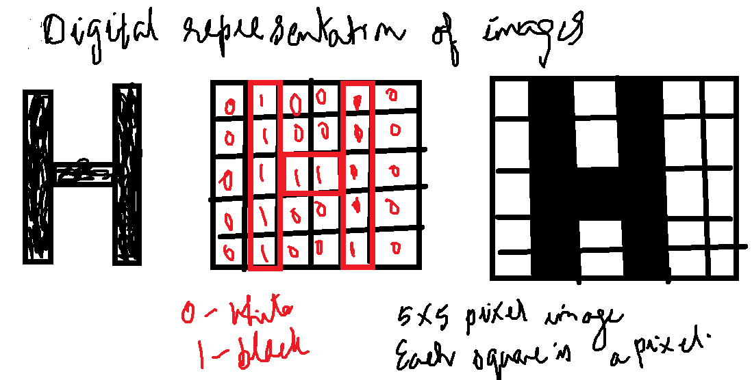

How does human recognize it is a car. Characteristics that are unique to the car – look for wheels, head lights , doors , glass windows and other features that distinguish it from other means of transport. When recognizing wheel , we look for circular objects , dark colored positioned below the main structure of the car. We take into account all little details that constitute to form the basic information. This information is bunched together to form a particular characteristic that is unique to the object that we are identifying.

Yaan LeCun , director of FaceBook AI group is the pioneer of the convolutional neural network.

Application of CNN:
Facial recognition in Social Media
Object detection in Self driving cars.
Disease detection using visual images.

ANN vs CNN
Criteria | ANN | CNN
Architecture | Multilayer Perceptrons | Convolutional layers , pooling layer and fully connected layers
Feature Extraction | Learned features through weights and biases | Learned features through convolution layers
Spatial Information | Not designed to capture spatial information | Specifically designed to capture spatial information
Parameter sharing | No parameter sharing | Parameter sharing through convolutional layers.
Scalability | Less scalable because of high number of parameters | More scalable due to shared parameters.
Training data | Large amount of training data | More efficient use of training due to parameter sharing.
Transfer learning | Less effective for transfer learning | Effective for transfer learning due to pre-trained models on large datasets.
Computational Efficiency | Less efficient for large images | More efficient for large images
Meaning of convolution
English meaning: Complex or difficult to understand, coil or twist.
Mathematical meaning: Operation on two functions that produces a third function that expresses how the shape of one is modified by other.

